Lab 5: Conditionals
IT 1090C Computer Programming I
IT 6090C Java Programming
Prof. Jason Geanuracos
Fall 2025

Lab 5: Conditionals
20 Points

Learning Goals:
- Conditional Structures in Java if, if else, cascaded if, nested if, switch
- Input with Scanner
- Testing. Make sure your programs run by testing them. Correct them if they do not.
Complete the lab individually: submit all the work and screenshots. Complete each of the programs here. (I may do the first with you in class.) These are programs that we previously did as pseudo code. Copy or re-write the pseudo code as single line // java comments as an outline for your program. Create a separate IntelliJ java project for each program using the names I specified.
Screenshot shortcut keys
- Windows: Alt + printScrn key puts image of desktop in clipboard. Then paste (ctrl+v) it into the document. You can also use Opt (Start) + Shift + s to bring up a cropping tool and paste that into your document. This may be easier. Also, you can hit Start + v to bring up the clipboard if you would like to screenshot multiple pictures and then paste all at once.
- Mac: Shift + Command + 3 or Shift + Command + 4 to capture a portion of the screen. Then, paste (command + v) it into the document.

Instructions
Remember to code the pseudo code for your program first within the java main() section as single line comments // comment….. Then, code the java statements for the pseudo code.
In each task, use a test suite that covers each of the logical paths the program can take. e.g. (for the first program) the user enters an item less than $100, or the user enters one > $100 Your screenshots should support that you did this testing! (Provide shots for each case, for each task.)
We will use scanner for input. Since we can't loop yet, we can only halt the program under control if the user makes an error. Later, we can loop back and repeat until they get it right.

Mini lecture:

Using Scanner for input in Java:
We use the Scanner class to get input from the user through the console. We have to import the Scanner class and create an instance of Scanner using the default input stream System.in.
import java.util.Scanner; // imports go at the top of the file BEFORE the class!
Scanner in = new Scanner(System.in); // it is very common to name the Scanner "in" or console

// Scanner has a variety of methods that read data of a specific Java type:
int val = in.nextInt(); // reads an int value throws an error if the input cannot be an int
double doubleVal = in.nextDouble(); // reads a double value error if the input isn't a double
String line = in.nextLine(); // reads an entire line to a \n newline character as a String
String word = in.next(); // reads part of the line up to a delimiter (space) or the \n … we don’t use this much its better to read the entire buffer not bit by bit.

The methods that return numeric types can throw an error if the input cannot be parsed into the correct type. The following methods allow you to safely determine if you can successfully read the numeric value. You must use these check functions every time you read in a number with the Scanner
in.hasNextInt(); // returns true if nextInt will succeed
in.hasNextDouble(); // returns true if nextDouble will succeed
You also have to clear the input buffer after reading a number with:
in.nextLine();

if and if .. else
Since anything the user types can be read in as a legal java String, the next() and nextLine() methods cannot generate an error; we will need to use the java structures if and if .. else for this. Let's look at the java Conditional Structures (if.. if .. else …, cascade if, cross product if).

if
if (CONDITION)
{
Code statements in this block execute if the CONDITION is true
} // this is the end of the block like the endIf in our pseudo code

if..else:
if (CONDITION)
{
Code statements in this block execute if the CONDITION is true
}
else
{
Code statements in this block execute if the CONDITION is false
} // this is the end of the block like the endIf in our pseudo code

Cascaded if:
if(CONDITION)
{
}
else if (CONDITON)
{
}
// more else if (CONDITON) blocks can go here
else // no condition a default when all the other if tests fail
{
}

Example 1
Here is an example code fragment that shows how to safely input a number:
import java.util.Scanner; // before the class at top of the file
// this code is in main:
Scanner in = new Scanner(System.in); // create a Scanner in to read from the console
double wage = 0;
System.out.print("Enter your hourly wage: ");

if(in.hasNextDouble())
{
// OK safe to read in a double
wage = in.nextDouble();
in.nextLine(); // clear the buffer
System.out.println("\nYou said your wage was: " + wage);
}
In the example above, we leave wage equal to 0 if the user enters something other than a valid amount. (i.e. double)

Example 2
Here is a better approach with if else: USE THIS!
import java.util.Scanner; // before the class at top of the file
// this code in main:
Scanner in = new Scanner(System.in);
double wage = 0;
String trash = ""; // use for bad input which will read as a String
System.out.print("Enter your hourly wage: ");

if(in.hasNextDouble())
{
// OK safe to read in a double
wage = in.nextDouble();
in.nextLine(); // clears the newline from the buffer
}
else
{
// Not a double can't use nextDouble() read as String with nextLine() instead
trash = in.nextLine(); // Ok have to read the input as a String
System.out.println("\nYou said your wage was: " + trash);
System.out.println("Run the program again and enter a valid amount!");
}

Lab
For this lab, you will create a separate IntelliJ project and GitHub repo for each task. That is to get you used to doing this. In future labs, we’ll create a single IntelliJ Project and GitHub repo with several programs.

Instructions
For each Task, create a new Java file with the specified name and include a main method OR rename the existing main.java. Add your new file to GitHub source control and commit it.
As you test each program, you must run it multiple times.
You may copy the output window from IntelliJ into this doc for EACH test run. There will be several for each program. If you prefer screenshots and can crop them effectively do that instead.
Make sure your output is readable, that's what we use to grade your work. You need to include the GitHub links for points.

Task 1 (5 pts):
Project name: ShipCostCalculator
An application program where the user enters the price of an item and the program computes shipping costs. If the item price is $100 or more, then shipping is free otherwise it is 2% of the price.
The program should output the shipping cost and the total price.

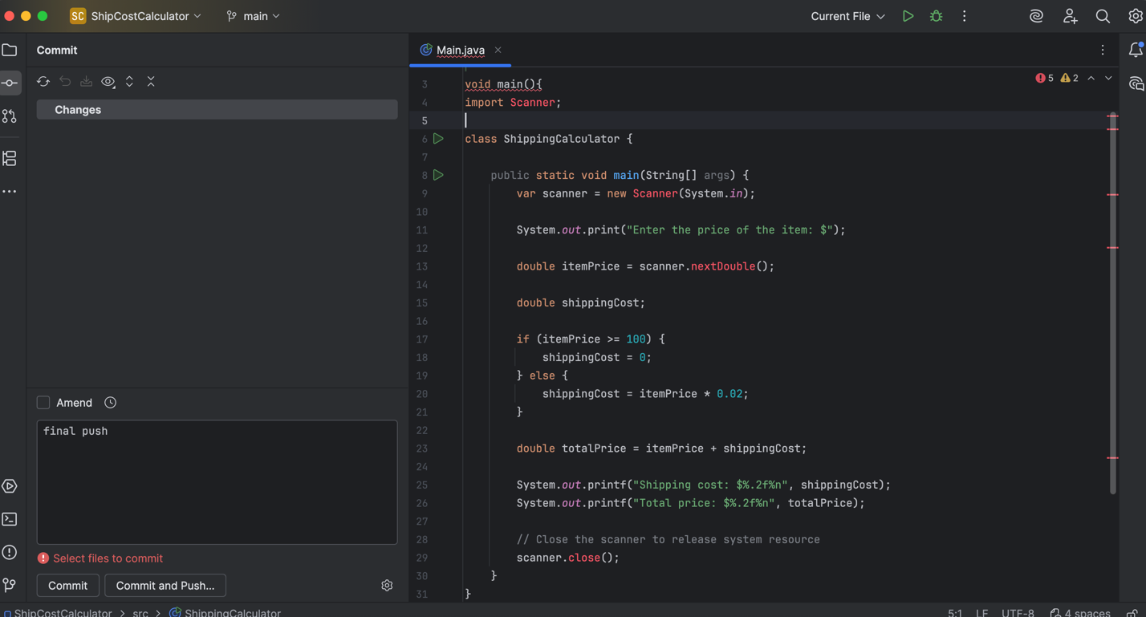

GitHub: Be sure to create the repo and add the file and commit and push it.
Paste the repo here for this task:
https://github.com/boehmjs/ShipCostCalculator

Task 2 (5 pts):
Project name: BirthMonth
A program that asks the user to enter their birth month (integer 1 – 12 inclusive). If the user enters a value in range, the program echoes the input ("Your birth month is: N") If the value is not in the range it outputs an error msg ("You entered an incorrect month value: N"). Here N should be the value they entered.
Test runs: (Insert screenshots here for the test runs)
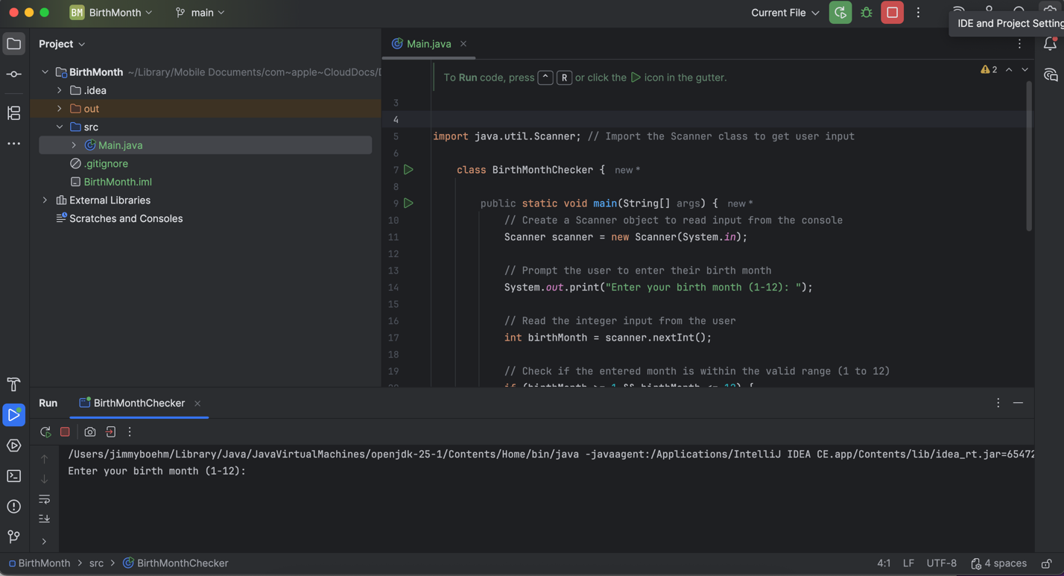
GitHub: Be sure to create the repo and add the file and commit and push it.
Paste the repo here for this task:
https://github.com/boehmjs/BirthMonth

Task 3 (5 pts):
Project name: PartyAffiliation
(This task uses Strings:) A program that prompts the user for their party affiliation (Democrat, Republican, or Independent) they respond with the first letter, and the program responds accordingly with a Donkey, Elephant, Person, or Other. (i.e. "You get a Democratic Donkey.")
Notes: create a menu so the user chooses D, R, or I and assume that any other choice will be Other.
Tests: just the four options D, R, I, Other. Use as cascaded if structure not separate if statements!
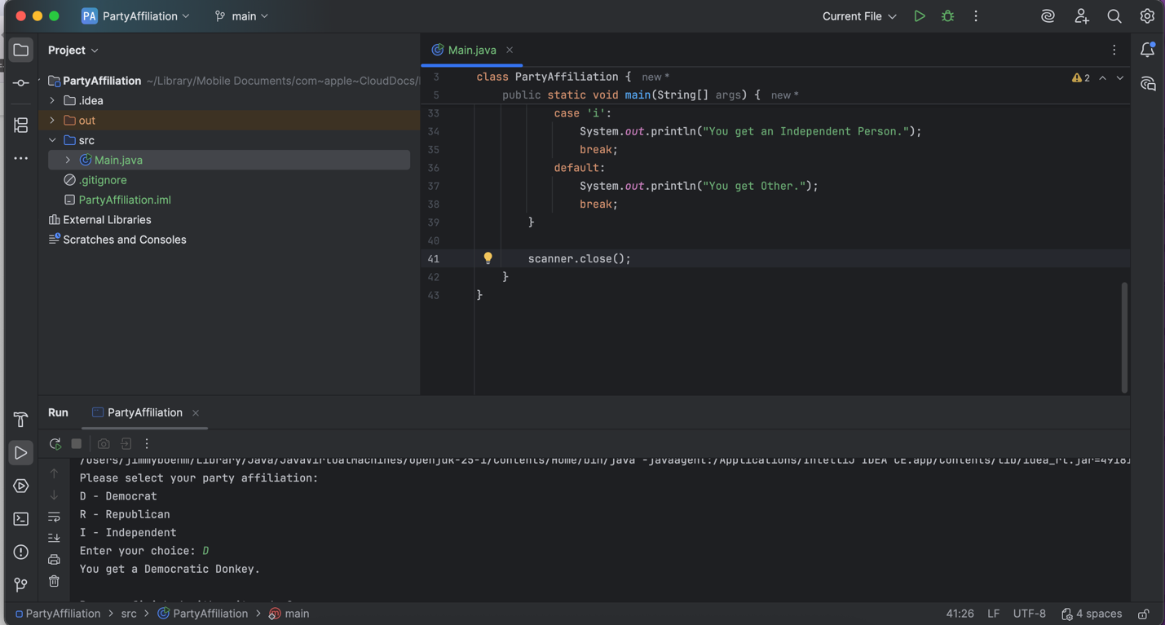
GitHub: Be sure to create the repo and add the file and commit and push it.
Paste the repo here for this task:
https://github.com/boehmjs/PartyAffiliation

Task 4 (5 pts):
Project name: TheaterKiosk
As people pass through an entry kiosk at the theater, they are prompted to enter their age. If they are 21 or older, they get a paper wrist band. Code a logic program that asks the user to enter their age and then if they are 21 or over displays a message that they get a wrist band.
Note that 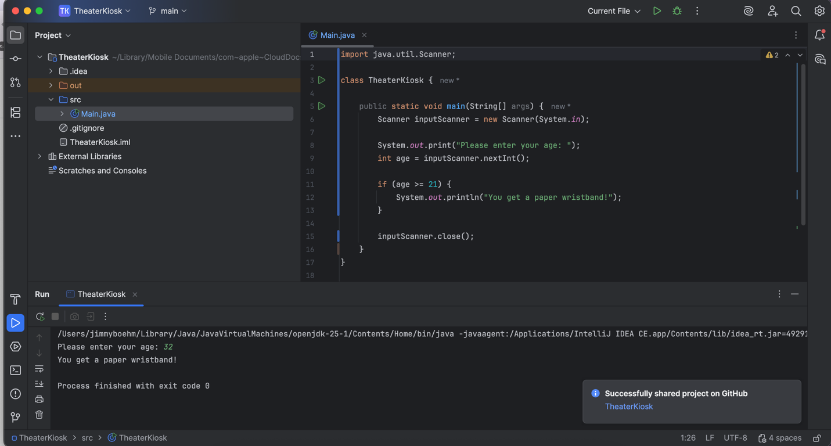the program does nothing if they are not 21 or over…

GitHub: Be sure to create the repo and add the file and commit and push it.
Paste the repo here for this task:
https://github.com/boehmjs/TheaterKiosk

Post-Lab: Double-check Your Work
Now that you have completed the lab tasks, build constructive professional work habits by carefully rechecking your work, and abiding by the naming format and submission instructions.

Rename the file:
Use the YourLastname_YourFirstname_Lab05.docx format; remember to replace "YourLastname" and "YourFirstname" with your actual names.
The naming format will help us efficiently track and organize your files. As you work on more projects the organization could become an issue if you do not follow this convention. pp

Submit
Submit to Canvas using the assignments mechanism to upload your document. Don’t submit a link to your document.

